A chemical substance that can react (in place of the substrate) with the enzyme but is not transformed into a product/s and thus blocks the active site temporarily or permanently is called
A. Co-enzyme
B. Blocker
C. Inhibitor
D. Cofactor
ANSWER: C
The curves show the rates of reaction of an enzyme with and without inhibitors
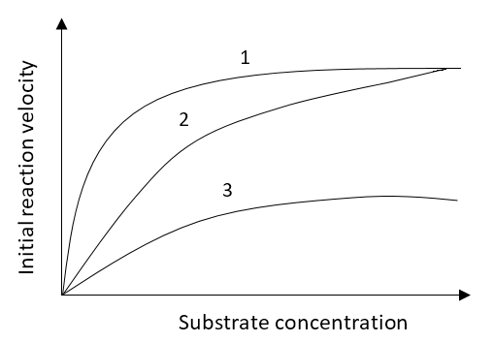
What do the curves show?
 | Curve 1 | Curve 2 | Curve 3
A. | Competitive inhibition | Non-competitive inhibition | Normal activity
B. | Competitive inhibition | Normal activity | Non-competitive inhibition
C. | Normal activity | Competitive inhibition | Non-competitive inhibition
D. | Normal activity | Non-competitive inhibition | Competitive inhibition
ANSWER: C
Which molecule binds to the active site of an enzyme?
A. Allosteric activator
B. Allosteric inhibitor
C. Non-competitive inhibitor
D. Competitive inhibitor
ANSWER: D
In non-competitive inhibition, a molecule binds to an enzyme at a site called:
A. Allosteric site
B. Active site
C. Catalytic site
D. None of these
ANSWER: A
Malonic acid is an example of:
A. Irreversible inhibitor
B. Reversible inhibitor
C. Competitive inhibitor
D. Non-competitive inhibitor
ANSWER: C
______________ block the enzyme activity and strongly resemble the real substrate of the enzyme
A. Non-competitive inhibitors
B. Activator
C. Competitive inhibitors
D. Uncompetitive inhibitors
ANSWER: C
A ___________ binds to a site other than where the substrate binds
A. Non-competitive inhibitors
B. Activator
C. Competitive inhibitors
D. Uncompetitive inhibitors
ANSWER: A
The other binding site of an enzyme is called:
A. Non-catalytic site
B. Allosteric site
C. Active site
D. Catalytic site
ANSWER: B
______ inhibitors obstruct enzymatic reactions by binding to a part of enzyme away from active site
A. Competitive
B. Non-competitive
C. Feedback inhibition
D. All of these
ANSWER: B
This inhibitor molecule blocks the active site:
A. Competitive inhibitors
B. Non-competitive inhibitors
C. Uncompetitive inhibitors
D. Irreversible inhibitors
ANSWER: A
This molecule binds to an enzyme somewhere other than the active site and reduces how effectively it works
A. Competitive inhibitors
B. Non-competitive inhibitors
C. Uncompetitive inhibitors
D. Irreversible inhibitors
ANSWER: B
Which of the following destroys the enzyme by altering its shape so that the substrate cannot bind to the active site
A. Activator
B. Reversible inhibitors
C. Uncompetitive inhibitors
D. Irreversible inhibitors
ANSWER: D
Example(s) of irreversible non-competitive inhibitors include:
A. Cyanides
B. Salts of heavy metals
C. Both A and B
D. Malonate
ANSWER: C
Feedback inhibition is a cellular control mechanism in which an enzyme’s activity is inhibited by the enzyme’s end product
A. Feedback inhibition
B. Feedback activation
C. Allosteric activation
D. Allosteric inhibition
ANSWER: A
Radiations may affect the enzyme and takes part in:
A. Inactivity
B. Activity
C. No change
D. None of these
ANSWER: A
The activity of almost every enzyme in a cell is regulated by:
A. Feedback inhibition
B. Feedback activation
C. Allosteric activation
D. Allosteric inhibition
ANSWER: A
When the product binds with the enzyme’s active site, the process is called:
A. Feedback inhibition
B. Feedback activation
C. Allosteric activation
D. Allosteric inhibition
ANSWER: A
Feedback inhibition is:
A. competitive inhibition
B. non-competitive inhibition
C. Both A and B
D. None of these
ANSWER: B
Failure of an enzyme to catalyze a reaction is referred to as:
A. Enzyme inhibition
B. Enzyme inhibitors
C. Feedback inhibition
D. Competitive inhibition
ANSWER: A
A molecule that binds to an enzyme but does not form the product is called:
A. Enzyme inhibition
B. Enzyme inhibitors
C. Feedback inhibition
D. Competitive inhibition
ANSWER: B
Inhibition may be:
A. Competitive
B. Non-competitive
C. Both A and B
D. None of these
ANSWER: C
Which of the following molecule act as inhibitor?
A. Cyanide
B. Penicillin
C. Sulpha drug
D. All of these
ANSWER: D
A molecule other than the substrate binds to the enzyme’s active site, causing
A. Competitive inhibition
B. Non-competitive inhibition
C. Both A and B
D. None of these
ANSWER: A
A molecule binds to a location other than the active site (an allosteric site) causing
A. Competitive inhibition
B. Non-competitive inhibition
C. Both A and B
D. None of these
ANSWER: B
Malonic acid is an example of:
A. Irreversible inhibitor
B. Reversible inhibitor
C. Competitive inhibitor
D. Non-competitive inhibitor
ANSWER: C
Which of the following destroys the enzyme by altering its shape so that the substrate cannot bind to the active site
A. Activator
B. Reversible inhibitors
C. Uncompetitive inhibitors
D. Irreversible inhibitors
ANSWER: D

